Google Dorking Investigation
Google Dorking Investigation is a technique of gathering information without triggering the target it’s the information available over the internet so we don’t have to worry about triggers or alerts.

- Public documents (PDF, DOC, XLS):
To find public documents pdf or docs file we use …
COMMAND: ( Site: <NAME OF WEBSITE> filetype <FILE TYPE>)
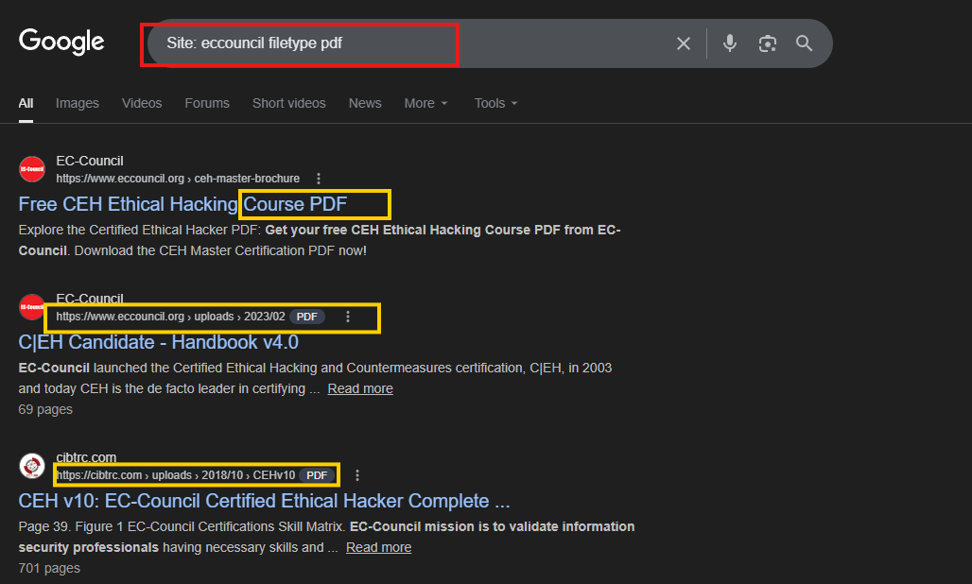
- Login portals:
To find hidden log in portals we will use…
Command: (Site: <Name of site> Inurl:login)
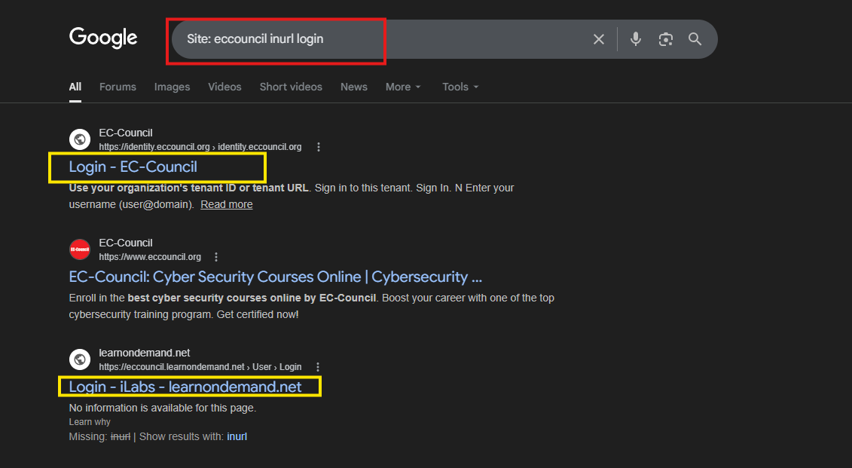

- Email formats:
Command: (Site :<NAME OF SITE> File type EMAILS)
- 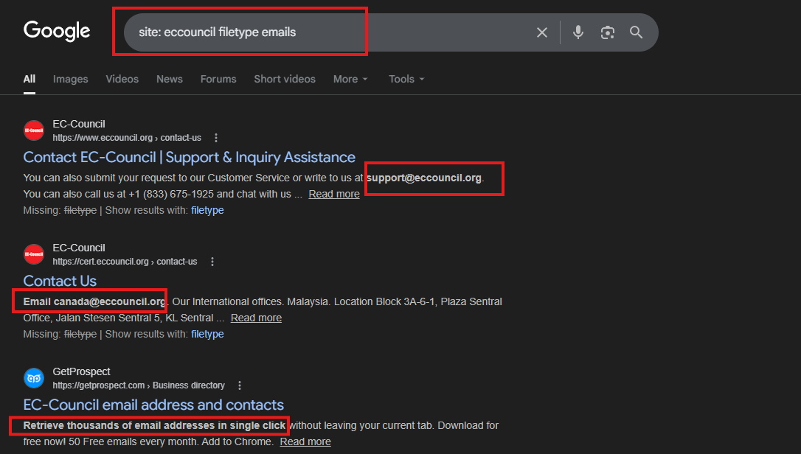 Subdomains:
To find subdomains of the target we use site:* to search on google.
Command: (site:*.eccouncil.org -site:www.eccouncil.org)
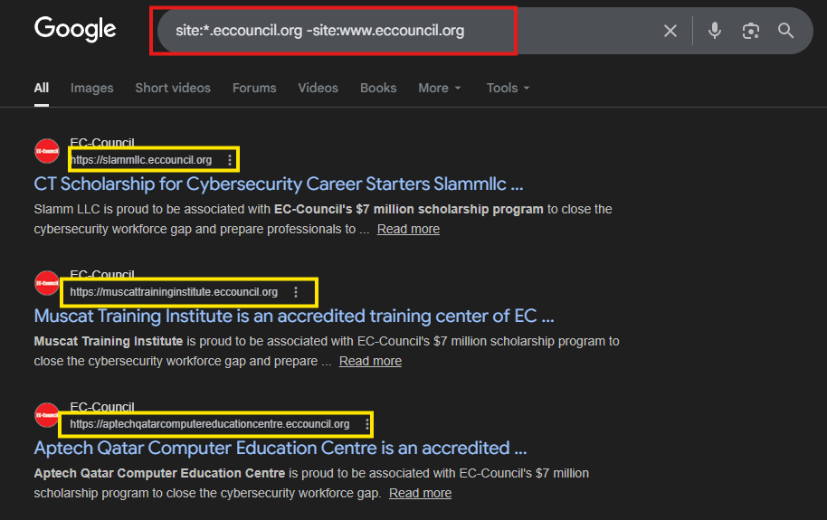
- Exposed directories
To find exposed directories we will use intitle index of (target)
Command (intitle index of eccouncil.org)

